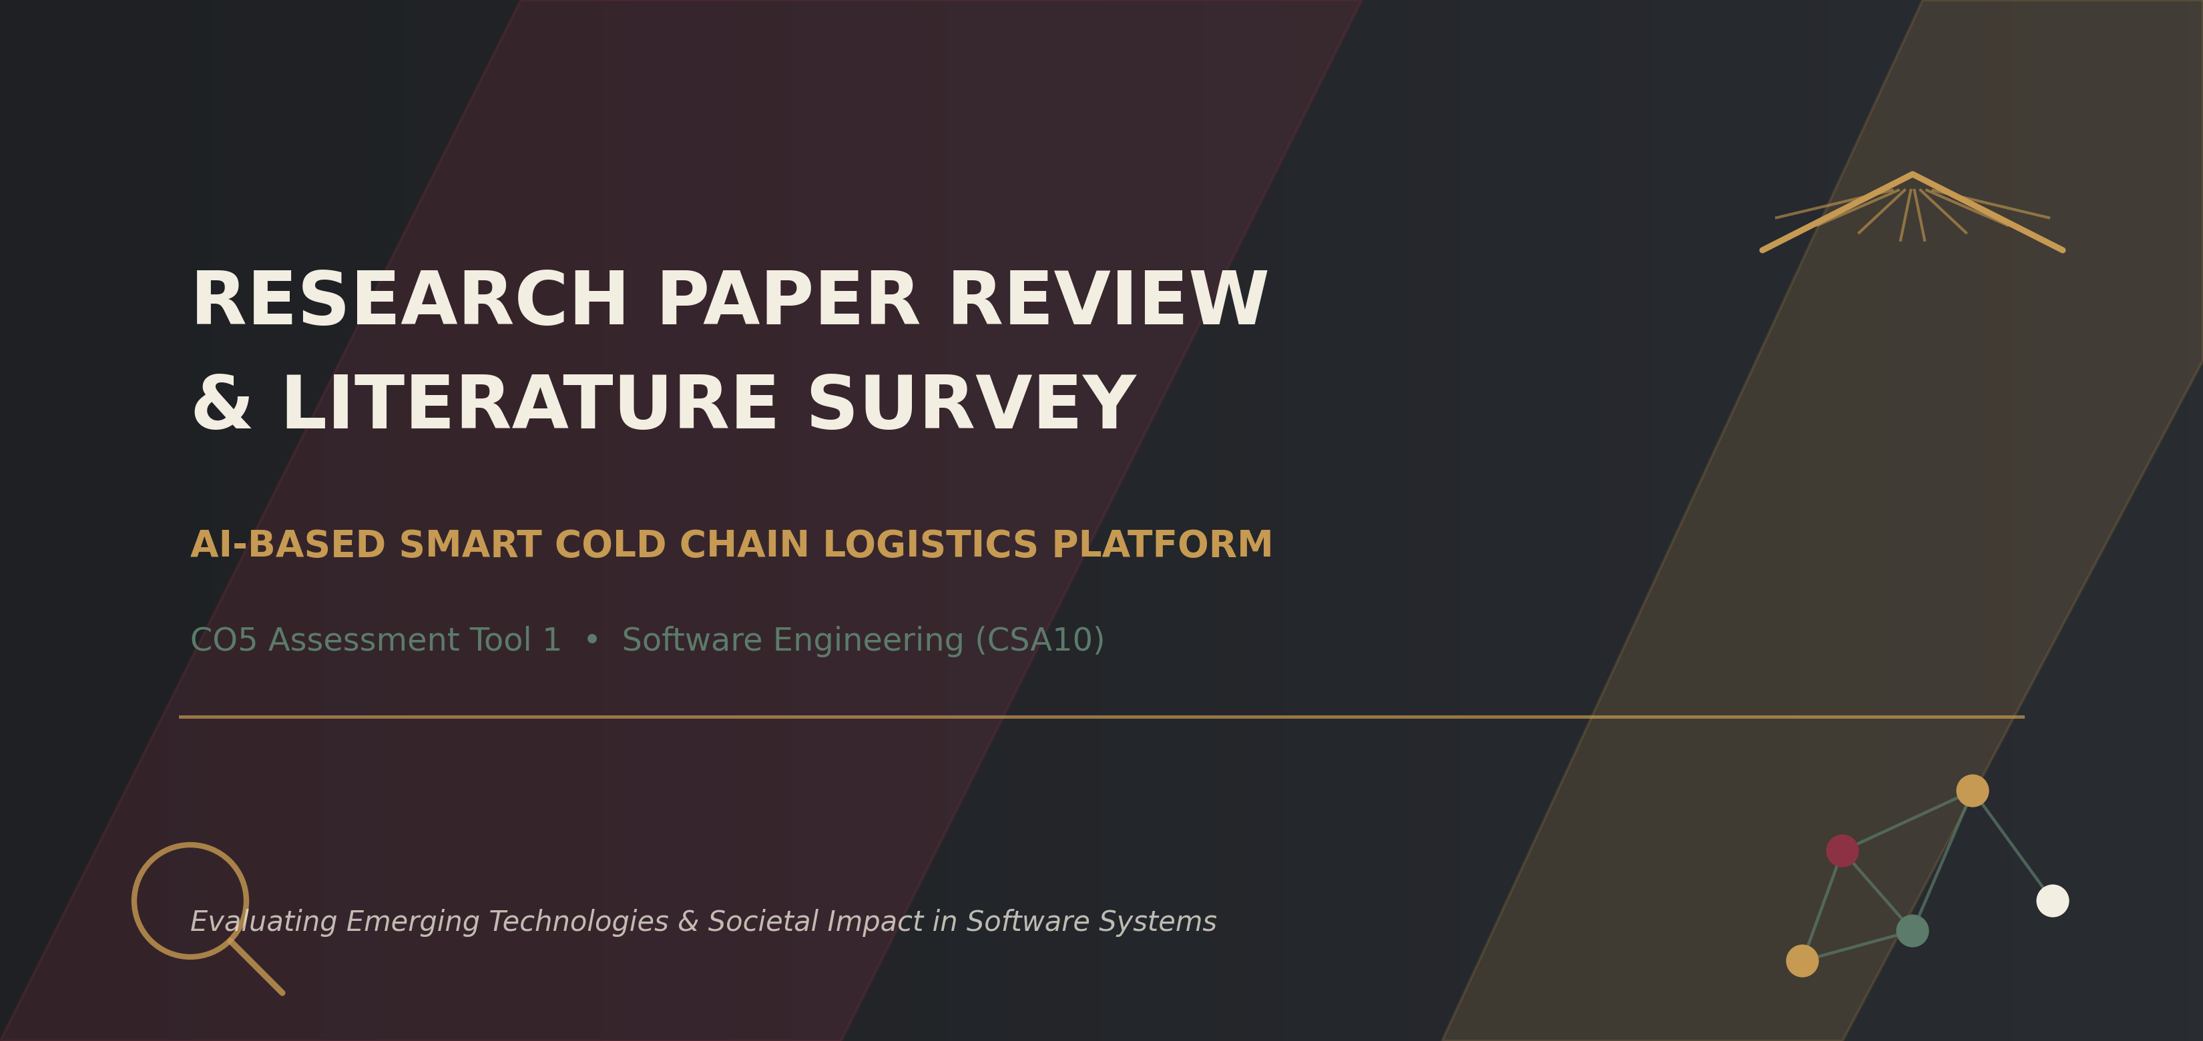

Student Name | Manisha
Register Number | 192424130
Course | CSA10 — Software Engineering
CO Assessed | CO5 — Evaluate emerging technologies and societal impacts, maintaining and evolving software systems responsibly
Assessment | Assessment Tool 1 — Research Paper Review / Literature Survey (Weightage 20%, Total Marks 25)
Assigned System | AI-Based Smart Cold Chain Logistics Monitoring and Optimization Platform

1. Introduction & Problem Context
The AI-Based Smart Cold Chain Logistics Monitoring and Optimization Platform depends on four capabilities working together: continuous IoT sensing of temperature and humidity, machine-learning prediction of refrigeration equipment failure, route optimization for delivery, and secure, traceable alerting. Each of these capabilities is an active research area in its own right. This literature survey reviews six recent, credible research papers spanning these areas, compares their methodologies and results, identifies where existing research falls short, and proposes future directions that are directly relevant to the assigned platform.
Scope of the Survey
- IoT-based real-time environmental monitoring and energy-aware cold chain sensing.
- Deep learning and ensemble models for cold chain temperature/loading-environment forecasting.
- Machine learning for predictive maintenance and equipment failure prediction.
- Vehicle routing and route optimization for cold chain distribution.
- AI, IoT and blockchain integration for security and traceability in perishable logistics
- .

2. Literature Survey Methodology
Papers were selected from peer-reviewed journals (Sensors, Entropy, PeerJ Computer Science, Energy Informatics, International Journal of Environmental Research and Public Health, Emerging Science Journal) published between 2019 and 2025, prioritizing recent, credible sources with clearly reported methodology and quantitative results. The survey then followed a consistent six-step process from selection through to future directions.
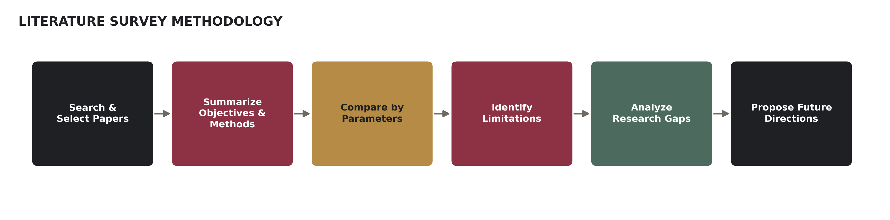
Figure 2.1 — Methodology followed for this literature survey

3. Individual Paper Reviews
P1 Real-Time IoT Monitoring with LSTM-PSO Energy Management for Cold Chain Logistics
Wang, K., & Du, N. (2025). Real-time monitoring and energy consumption management strategy of cold chain logistics based on the internet of things. Energy Informatics, 8(1).
Objective & Methodology: The study addresses the high energy consumption and low operational efficiency of conventional cold chain monitoring by combining a distributed IoT sensor architecture with a data-driven energy management strategy. A distributed system of sensor nodes and communication modules (NB-IoT, LoRa) collects temperature, humidity and equipment data in real time; a Long Short-Term Memory (LSTM) network forecasts energy demand while a Particle Swarm Optimization (PSO) algorithm schedules equipment operation, tested in a simulated cold chain scenario.
Key Findings: Compared to a traditional system, energy consumption fell by about 20%, temperature/humidity control accuracy reached 94%, and transport time shortened by 8.33%, demonstrating that combining forecasting with optimization improves both efficiency and environmental control simultaneously.
P2 K-medoids-LSTM-XGBoost Ensemble for Cold Chain Loading Environment Prediction
Luo, Z., Liu, W., Wu, J., Aiqing, H., & Guo, J. (2024). Prediction of cold chain loading environment for agricultural products based on K-medoids-LSTM-XGBoost ensemble model. PeerJ Computer Science, 10, e2510.
Objective & Methodology: The paper targets the difficulty of maintaining an appropriate temperature during cold chain loading, where a delay between activating refrigeration and reaching target temperature wastes energy and risks product quality. Historical loading-environment temperature data is first clustered and fused using the K-medoids algorithm, then fed into a combined LSTM-XGBoost ensemble that predicts future temperature over a defined horizon, benchmarked against individual LSTM, XGBoost and other ensemble baselines.
Key Findings: The ensemble model achieved a mean absolute error of 2.5343, outperforming individual and comparable ensemble models, showing that combining clustering-based data fusion with hybrid deep learning improves short-term cold chain temperature forecasting accuracy.
P3 Machine Learning Predictive Maintenance for Refrigeration-Adjacent Industrial Equipment
Aminzadeh, A., Sattarpanah Karganroudi, S., Majidi, S., Dabompre, C., Azaiez, K., Mitride, C., & Sénéchal, E. (2025). A Machine Learning Implementation to Predictive Maintenance and Monitoring of Industrial Compressors. Sensors, 25(4), 1006.
Objective & Methodology: The study aims to shift industrial compressor maintenance from reactive to proactive by predicting failures before they occur, directly analogous to predicting refrigeration-unit failure in a cold chain fleet. Temperature, pressure and flow-rate sensors feed a cloud-connected SQL database; a Linear Regression model is trained on this multi-sensor data and deployed for real-time inference, triggering an automated warning email when readings exceed a learned threshold.
Key Findings: The deployed model reached 98% accuracy (Mean Squared Error metric) in anticipating equipment issues, confirming that even a comparatively simple regression model can deliver strong predictive-maintenance results when paired with well-instrumented multi-sensor data.
P4 Genetic Algorithm Route Optimization Under Traffic Uncertainty for Cold Chain Joint Distribution
Shi, H., Hong, Y., Zhang, Q., & Qin, J. (2025). Research on Cold Chain Logistics Joint Distribution Vehicle Routing Optimization Based on Uncertainty Entropy and Time-Varying Network. Entropy, 27(5), 540.
Objective & Methodology: The paper addresses route planning for multiple cold chain distribution centers sharing vehicles and storage (joint distribution), while accounting for traffic congestion uncertainty that earlier joint-distribution studies overlooked. A Cold Chain Logistics Joint Distribution Vehicle Routing Problem with Time-Varying Network (CCLJDVRP-TVN) model is solved using simulated annealing combined with a genetic algorithm, with an entropy mechanism specifically added to manage traffic-congestion uncertainty; validated on real data from three cold chain companies in Beijing.
Key Findings: The approach reduced total logistics cost by 18.3%, carbon emissions by 15.8%, and required fleet size by 12.5% versus the baseline, showing that modelling uncertainty explicitly (not just distance and time windows) meaningfully improves route optimization outcomes.
P5 Vehicle Routing Balancing Cost, Customer Satisfaction and Carbon Emissions
Qin, G., Tao, F., & Li, L. (2019). A Vehicle Routing Optimization Problem for Cold Chain Logistics Considering Customer Satisfaction and Carbon Emissions. International Journal of Environmental Research and Public Health, 16(4), 576.
Objective & Methodology: The study argues that optimizing cold chain routes for cost alone ignores two factors that matter commercially and environmentally: on-time delivery (customer satisfaction) and carbon cost under carbon-trading schemes. A vehicle routing model is formulated with the objective of minimizing cost per satisfied customer, combining delivery punctuality as the satisfaction metric with a carbon-trading cost term; solved with a cycle evolutionary genetic algorithm and validated against real case data.
Key Findings: Results show a small increase in total cost can substantially raise average customer satisfaction, and that carbon price has competing effects — reducing emissions but also reducing satisfaction beyond a certain point — highlighting a genuine cost/satisfaction/emissions trade-off that single-objective models miss.
P6 Integrated AI, IoT and Blockchain for Security and Traceability in Perishable Logistics
Villegas-Ch, W., Gutierrez, R., Govea, J., & García-Ortiz, J. (2025). Integrated AI, IoT, and Blockchain for Enhancing Security and Traceability in Perishable Logistics. Emerging Science Journal, 9(5).
Objective & Methodology: The paper responds to the risk that perishable-goods supply chains face from both quality degradation and data tampering, arguing that monitoring alone is insufficient without verifiable, tamper-resistant traceability. An architecture combining IoT-based cold chain sensing, AI-driven anomaly detection on the resulting sensor streams, and blockchain-based ledger recording is proposed so that every monitored event is both intelligently flagged and immutably logged.
Key Findings: The integrated design demonstrates that anomaly detection and blockchain traceability are complementary rather than redundant: AI catches quality-threatening events in real time, while blockchain ensures the record of those events cannot be altered after the fact, strengthening both safety and auditability.

4. Comparative Literature Survey Table
The table below compares all six reviewed papers across author/year, research problem, methodology, dataset/tools, key findings, limitations, and the research gap each leaves open.
Author/Year | Research Problem | Methodology | Dataset/Tools | Key Findings | Limitations | Research Gap
Wang & Du (2025) | High energy use & low efficiency in cold chain monitoring | IoT sensor network + LSTM forecasting + PSO scheduling | Simulated cold chain scenario; NB-IoT/LoRa sensors | 20% energy cut; 94% temp/humidity accuracy; 8.33% faster transport | Simulated, not field-deployed; single-fleet scope | No validation at multi-region, real-traffic scale
Luo et al. (2024) | Inaccurate short-term cold chain loading temperature prediction | K-medoids clustering + LSTM-XGBoost ensemble | Agricultural product loading-environment temperature dataset | MAE 2.5343; outperforms individual & other ensemble models | Focused on loading phase only, not full transit | No integration with route or failure-prediction models
Aminzadeh et al. (2025) | Reactive maintenance causes unplanned compressor downtime | IoT sensor fusion + Linear Regression + SQL pipeline | Temperature, pressure, flow-rate sensor data; industrial compressor | 98% accuracy (MSE); automated threshold-based alerting | Simple model may not capture complex nonlinear faults | No comparison against deep learning failure-prediction models
Shi et al. (2025) | Joint distribution routing ignores traffic uncertainty | Genetic algorithm + simulated annealing + entropy mechanism | Real operational data, 3 cold chain firms, Beijing | 18.3% cost cut; 15.8% carbon cut; 12.5% fleet cut | City-specific validation; heuristic, not guaranteed optimal | No coupling with real-time sensor/failure data during routing
Qin et al. (2019) | Cost-only routing ignores satisfaction & carbon trade-offs | Cycle evolutionary genetic algorithm; cost-per-satisfied-customer objective | Real case data from a cold chain transport company | Small cost rise sharply improves satisfaction; carbon price trade-off quantified | Static demand; does not model dynamic/unknown orders | No mechanism for real-time re-routing under changing conditions
Villegas-Ch et al. (2025) | Monitoring alone cannot guarantee tamper-proof traceability | IoT sensing + AI anomaly detection + blockchain ledger | Conceptual/prototype perishable logistics architecture | AI detection and blockchain logging shown to be complementary | Limited large-scale performance/throughput evaluation | No study of blockchain overhead at high sensor-data volume

5. Comparative Analysis by Parameters
Beyond the qualitative comparison in Section 4, the reviewed papers report concrete quantitative outcomes across three different parameters — efficiency/accuracy, cost, and environmental impact — that can be compared directly.
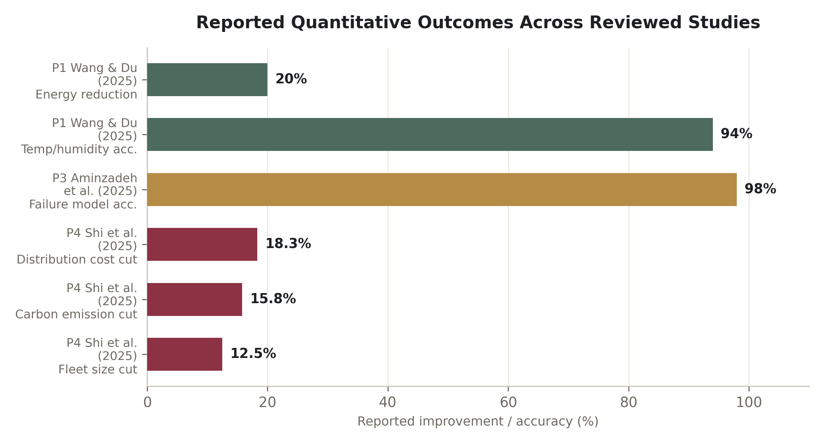
Figure 5.1 — Reported quantitative outcomes across the six reviewed studies
Comparison by Evaluation Parameter
Parameter | Strongest Performer | Observation
Predictive accuracy | P3 Aminzadeh et al. — 98% (MSE-based) | Even a simple regression model performs strongly with well-instrumented sensor fusion.
Forecasting error (lower is better) | P2 Luo et al. — MAE 2.5343 | Ensemble clustering + LSTM-XGBoost beats single-model baselines on the same data.
Cost efficiency | P4 Shi et al. — 18.3% cost reduction | Modelling traffic uncertainty explicitly outperforms static routing assumptions.
Environmental impact | P4 Shi et al. — 15.8% carbon reduction | Joint distribution plus uncertainty-aware routing reduces emissions meaningfully.
Real-world validation | P4 Shi et al. — tested on 3 real Beijing firms | Most other studies (P1, P2, P3, P6) remain simulation- or lab-scale.

6. Limitations & Challenges of Existing Approaches
Limitation | Papers Affected | Why It Matters
Simulation or single-site validation rather than multi-region field deployment. | P1, P2, P3, P6 | Real cold chains span many depots, vehicles and climates; a single test site may not generalize.
Each capability (monitoring, prediction, routing, security) studied largely in isolation. | P1–P6 | The assigned platform needs all four working together, not as separate research silos.
Limited model explainability for failure/anomaly predictions. | P3, P6 | Operators are less likely to trust or act on alerts they cannot understand.
Heuristic optimization (genetic algorithms, simulated annealing) offers no optimality guarantee. | P4, P5 | Good but not provably best routes; performance can vary with problem scale.
Static or simplified demand/traffic assumptions. | P2, P5 | Real logistics demand and congestion change continuously and unpredictably.
Little evaluation of system overhead at high data volume (e.g., blockchain throughput). | P6 | A platform monitoring hundreds of shipments needs to confirm this scales.

7. Research Gap Analysis
Reading across all six papers together, the individual limitations converge into five broader, recurring research gaps relevant to the assigned platform, summarized in the mindmap below.
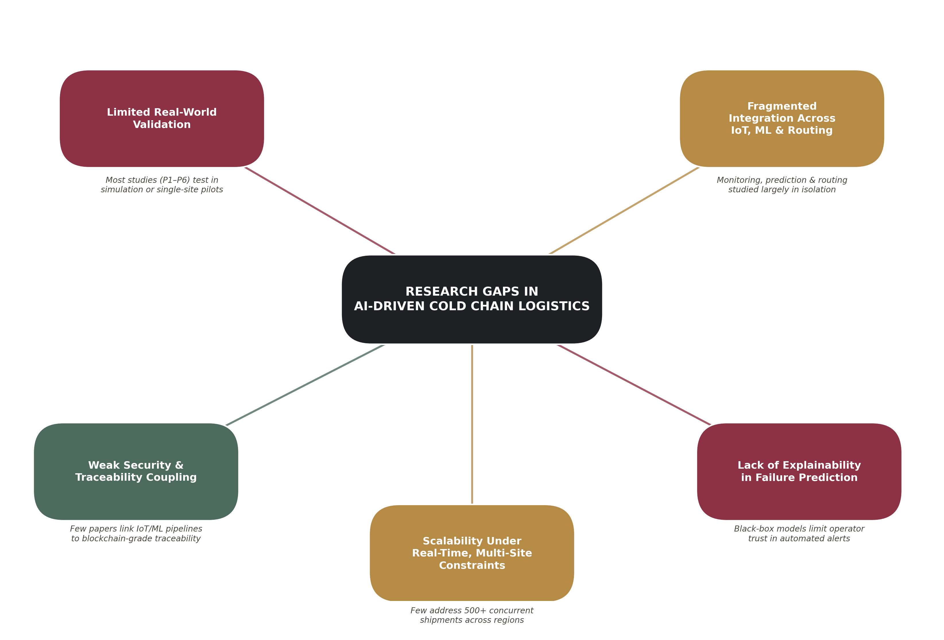
Figure 7.1 — Mindmap of research gaps identified across the reviewed literature

8. Future Research Directions
- Integrated pipeline research: study IoT monitoring, failure prediction, and route optimization as one coupled system (as the assigned platform requires) rather than as separate papers, to measure end-to-end gains and failure interactions.
- Field-scale validation: extend simulation-based studies (P1, P2, P3, P6) to multi-region pilots with real refrigerated fleets, closer to Shi et al.'s (2025) real-company validation approach.
- Explainable failure prediction: pair predictive-maintenance models like Aminzadeh et al. (2025) with interpretability methods (e.g., SHAP) so operators understand why an alert fired, building the trust needed for automated rollback/alert actions.
- Dynamic, uncertainty-aware routing at scale: combine Shi et al.'s (2025) entropy-based uncertainty modelling with Qin et al.'s (2019) satisfaction/carbon trade-off to optimize for cost, punctuality and emissions together, tested on larger multi-depot networks.
- Lightweight blockchain integration: evaluate the throughput and latency cost of Villegas-Ch et al.'s (2025) AI+blockchain architecture under realistic sensor data volumes, so traceability does not become the platform's own bottleneck.

Ethical / Societal Concern | Where It Arises in the Literature | Responsible Mitigation
Data privacy of shipment location and timing. | P1, P4, P5 all process continuous GPS and route data. | Aggregate/anonymize location logs once a delivery is complete; restrict raw GPS access by role.
Over-trusting black-box failure predictions. | P3's regression model and similar ML predictors give no explanation for an alert. | Pair predictions with explainability (Section 8) so a human always understands the “why” before acting.
Equitable service across regions. | P4, P5 optimize cost and satisfaction but were validated in one city/company context. | Test routing fairness across underserved or rural delivery regions, not only dense urban pilots.
Environmental accountability. | P1 and P4 report real energy and carbon reductions. | Report carbon/energy metrics transparently as a standard KPI, not just cost savings.
Tamper-resistant accountability for safety-critical goods (e.g., vaccines). | P6 pairs AI monitoring with blockchain logging. | Treat traceability as a core requirement for regulated cargo, not an optional add-on.
Taken together, these considerations show that evolving this platform “responsibly” is not a separate task from the technical work in Sections 3–8 — it means choosing explainable models over opaque ones where trust matters, testing fairness across regions rather than a single pilot site, and treating environmental reporting and tamper-proof traceability as first-class requirements alongside accuracy and cost.

Conclusion
This survey reviewed six recent, credible papers covering IoT-based cold chain monitoring, deep-learning environment forecasting, machine-learning predictive maintenance, uncertainty-aware and multi-objective route optimization, and AI-blockchain traceability. Each paper demonstrates strong results within its own scope — from 98% predictive-maintenance accuracy to an 18.3% logistics cost reduction — but the comparative analysis shows these capabilities are consistently researched in isolation and validated at limited scale. For the AI-Based Smart Cold Chain Logistics Platform, this points directly to the value of an integrated, field-validated, and explainable system: exactly the kind of platform CO5 asks students to evaluate and evolve responsibly, balancing technical performance with security, reliability, and real-world societal impact.

References
[1] Wang, K., & Du, N. (2025). Real-time monitoring and energy consumption management strategy of cold chain logistics based on the internet of things. Energy Informatics, 8(1), 1–20. https://doi.org/10.1186/s42162-025-00493-w
[2] Luo, Z., Liu, W., Wu, J., Aiqing, H., & Guo, J. (2024). Prediction of cold chain loading environment for agricultural products based on K-medoids-LSTM-XGBoost ensemble model. PeerJ Computer Science, 10, e2510. https://doi.org/10.7717/peerj-cs.2510
[3] Aminzadeh, A., Sattarpanah Karganroudi, S., Majidi, S., Dabompre, C., Azaiez, K., Mitride, C., & Sénéchal, E. (2025). A machine learning implementation to predictive maintenance and monitoring of industrial compressors. Sensors, 25(4), 1006. https://doi.org/10.3390/s25041006
[4] Shi, H., Hong, Y., Zhang, Q., & Qin, J. (2025). Research on cold chain logistics joint distribution vehicle routing optimization based on uncertainty entropy and time-varying network. Entropy, 27(5), 540. https://doi.org/10.3390/e27050540
[5] Qin, G., Tao, F., & Li, L. (2019). A vehicle routing optimization problem for cold chain logistics considering customer satisfaction and carbon emissions. International Journal of Environmental Research and Public Health, 16(4), 576. https://doi.org/10.3390/ijerph16040576
[6] Villegas-Ch, W., Gutierrez, R., Govea, J., & García-Ortiz, J. (2025). Integrated AI, IoT, and blockchain for enhancing security and traceability in perishable logistics. Emerging Science Journal, 9(5).

